Windows Multi-WAN Aggregation Blueprint
Oct 17, 2026 · @Amir
Build a user-mode service with a Wintun virtual adapter and an encrypted multipath tunnel to a relay you operate, and add a custom WFP or NDIS driver only if lab measurements show the user-mode path cannot meet the targets.

Executive summary
Start with a relay-backed tunnel in user mode, because only a cooperating server can make one connection faster than your best single uplink, and Windows has no built-in way to do that.
- Load balancing is easy; bonding is not. Spreading separate connections across Wi-Fi, Ethernet and cellular needs no server. Making one download use all three at once needs a relay you run, or a multipath protocol that both ends support.
- Windows gives you no multipath transport. A 2024 university thesis states that Windows does not implement Multipath TCP. Multipath QUIC is still an IETF draft in the RFC Editor queue and leaves scheduling to the implementer.
- WFP and NDIS are interception points, not bonding engines. WFP callouts inspect, modify and reinject traffic. NDIS filter drivers sit between adapters and protocol drivers. You still have to write the scheduler, tunnel and reorder logic.
- Kernel code is the expensive part. It brings driver signing, memory-integrity testing and crash risk. Defer it behind measured go/no-go gates.
- Proof of concept in three steps: (1) a service that balances flows across uplinks, with the GUI shell; (2) a Wintun virtual adapter and an encrypted UDP tunnel to a relay; (3) a lab benchmark that decides whether any driver is needed.
- Hardest risks: unequal links (cellular against Wi-Fi) causing reordering and added delay; relay running costs and location; coexistence with VPN and security software; and the signing path if a driver is needed.

Requirements and scope
The blueprint targets Windows 11 on x64 and ARM64 with Wi-Fi, Ethernet and cellular uplinks, and treats single-flow bandwidth bonding as a separate goal that depends on a relay server.
Your requirement | How this blueprint reads it | Needs a remote server?
Windows-native, low latency, low overhead | Native user-mode service first; kernel code only if lab measurements justify it | No
Load balancing | Per-flow distribution of independent connections across uplinks | No
Bonding and seamless failover | Packet-level striping inside an encrypted tunnel; sessions survive an uplink loss | Yes, a relay you operate
Modern, responsive GUI | Separate desktop front-end that talks to the service over local IPC | No
Web presence | Static documentation site plus signed downloads and a winget package | No
Assumptions (mine, not yours — please correct any that are wrong)
- A1: Windows 11 24H2 or later is the primary target; Windows 10 22H2 is best effort.
- A2: You will run the relay yourself, for example on a rented server near your users.
- A3: The first customers are individuals and small offices, not managed enterprise fleets.
- A4: TCP, UDP and QUIC traffic over IPv4 and IPv6 must work from the first release.
Non-goals
- Windows Server, and Windows versions older than Windows 10.
- Bonding with no relay or other cooperating endpoint for a single connection.
- Circumventing carrier plan limits or metering.

Methodology comparison
Only packet-level bonding and transport multipath can lift one connection above your fastest uplink, and both need a cooperating server at the other end.
Method | One-flow speed / many-flow speed | Latency and reordering | Failover | Remote endpoint | Driver or privilege | Best fit
1. Policy routing (static rules per app or destination) | One uplink / low | Lowest overhead, no reordering | Manual or slow; live connections drop | No | Admin rights to change routes | Pin voice calls to Ethernet
2. Per-flow balancing (5-tuple hash) | One uplink / high | No reordering; each flow keeps its link's delay | New flows move, flows on the dead link reset | No | Service; source-address steering to validate | Browsing and many-connection downloads
3. Application-aware steering (process, port, DNS, SNI) | One uplink / high | Same as 2, with rules per traffic class | Same as 2 | No | Service; process data may need WFP | Games, calls and streams on the best link
4. Packet bonding with a relay (sequence numbers, reorder buffer) | Sum of links less overhead / high | Reorder buffer adds delay near the path-delay gap | Seamless; tunnel outlives any one uplink | Required | Virtual adapter plus service | Large single transfers, uplink video
5. Per-uplink tunnels with flow-level balancing | One tunnel / high | Like 2; encrypted | Fast with health checks; exit address stays stable | Required | Virtual adapter plus service | Stable public address, simpler state than 4
6. Transport multipath (MPTCP, multipath QUIC) | Sum of paths on supporting connections / high | Handled by the transport | Seamless at transport level | Both ends must support it | No Windows MPTCP; QUIC multipath lives in the library | Services you control end to end
Scores are my engineering judgments from the protocol designs, not measurements. Multipath TCP is a Proposed Standard (RFC 8684, March 2020) that carries one connection over several paths. The multipath QUIC draft says it does not specify how traffic is scheduled across paths.
NAT and effort. Methods 1 to 3 work behind any NAT because every flow keeps one uplink's address, but a server sees a new address if a flow moves. Methods 4 to 6 send outbound UDP from each uplink to a relay, which ordinary NAT allows. Deployment effort is lowest for method 1 and highest for methods 4 and 6.
Recommendation. Build method 5 first because it gives failover and a stable exit address with simple state. Add method 4 striping afterwards, only for flows where a measurement shows a gain.

Recommended architecture
Packets take one path through a signed adapter, a classifier, a scheduler and a tunnel, while a separate control plane sets weights and rules without ever touching them.
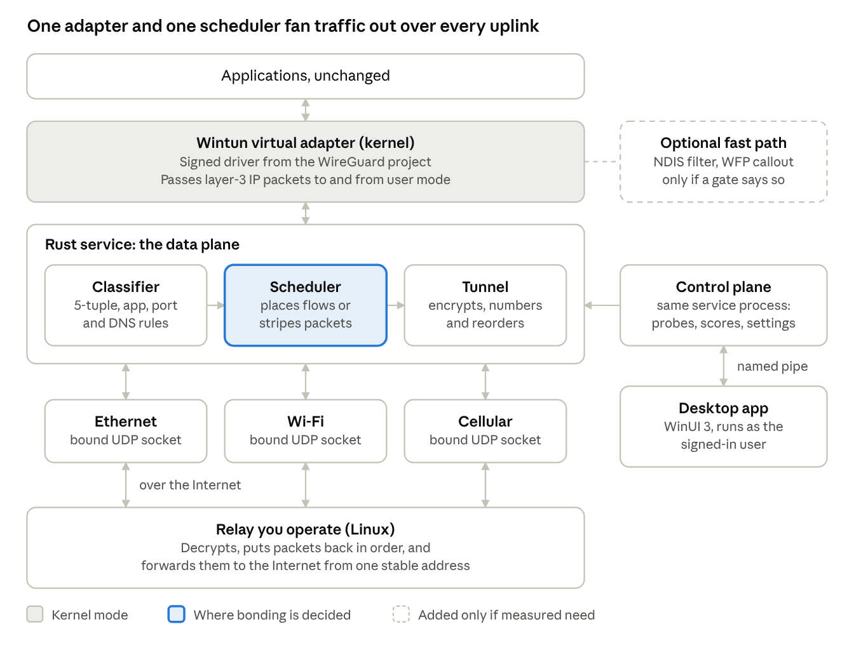
Windows client to relay · data plane and control plane
Traffic arrows run both ways; the dashed box is the one component you may never build.
- Data plane: the adapter hands IP packets to the service. The classifier sorts them, the scheduler picks an uplink, and the tunnel encrypts, numbers and sends them from a socket bound to that uplink. The relay reverses the steps.
- Control plane: probes, link scoring and settings live in the same service. The desktop app reaches them only through the named pipe.
- Trust boundaries: kernel mode (Wintun and any later driver), the service account, the signed-in user, and the relay. The relay is the only component reachable from the Internet, and the pipe is the only local way into the service.
- Failure points: uplink loss, relay loss and service crash are handled in the failover and security sections.

Windows integration choices
Use a Wintun adapter with a user-mode service for the first release; keep WFP for traffic classification and an NDIS filter as an optional fast path later.
Option | What it gives you | What it does not give you | Verdict
Service only (no driver) | Sockets the service opens itself, bound to a chosen uplink | A way to capture other apps' traffic, or a virtual adapter | Good for a throwaway balancer prototype
Wintun virtual adapter | A layer-3 adapter whose packets a user-mode program reads and writes; signed DLLs ship as a ZIP | Any scheduling or bonding; every packet still crosses into user mode | MVP choice for methods 4 and 5
WinDivert | User-mode capture, modify and reinject of packets, through a driver installed below the network stack | A virtual adapter; its README lists Windows 7 to 10, so Windows 11 needs testing | Backup route for steering without writing a driver
WFP filters and callout driver | Inspection, packet and stream modification, reinjection and logging at TCP/IP layers | A virtual adapter, a scheduler or a tunnel | Use for classification and redirect; a kernel callout needs signing
NDIS filter driver | Sees and modifies traffic between a miniport adapter and the protocol drivers; lighter than an intermediate driver | A new virtual NIC; it attaches to an existing adapter | Optional later fast path
Custom NDIS virtual miniport | Your own adapter with kernel-side batching | Maturity: Microsoft's sample is for education, not production | Only if Wintun misses the targets in the lab
Wintun's source is under GPL 2.0, while its prebuilt signed DLLs carry a separate, more permissive licence shipped in the ZIP. Check that licence with counsel before you commit to it.
Spike S1 (week 1). Prove that a user-mode socket can be forced out of a chosen uplink on Windows 11 when the routing table prefers another one. Test source-address binding, the per-interface strong and weak host settings, and the IP_UNICAST_IF socket option. Every later design choice depends on the result.

Load balancing, bonding and failover design
Keep two schedulers: one that places whole flows on uplinks, and one that stripes packets of a single flow across uplinks. Every number below is a proposed starting value to tune in the lab, not a measured result.
Flow placement (method 5).
- Hash each flow's 5-tuple with weighted rendezvous hashing over the healthy uplinks, so a link change moves only the flows that were on that link.
- Weight each uplink by its estimated capacity, discounted for loss and for round-trip time above the best uplink's.
- Pin a flow to its uplink until it idles out. Move it only when its uplink goes down.
- Send latency-sensitive classes (DNS, voice, game ports) to the lowest-delay healthy uplink instead of hashing them.
Packet striping (method 4).
- Number every tunnel packet. The relay holds packets in a reorder buffer and releases them in order.
- Choose the uplink per packet by deficit round robin, with each quantum proportional to that uplink's estimated capacity.
- Size the buffer's hold time from the measured delay gap between the slowest and fastest active uplinks, with a hard cap so one slow link cannot stall the flow.
- Run congestion control per uplink inside the tunnel. Encapsulate in UDP, never TCP, so the inner connection's own loss recovery keeps working.
- Offer an optional duplicate mode that sends small critical packets on two uplinks, at the price of extra bandwidth.
Path health and failover. Probe each uplink to the relay and also learn from tunnel acknowledgements.
State | Entered when | Traffic policy | Leaves when
Probing | Uplink appears or the machine resumes from sleep | None; probes only | Probes succeed, then Up
Up | Five consecutive probes answered (proposed) | Full weight | Loss or delay crosses the Degraded threshold
Degraded | Loss or delay above threshold | Weight reduced; no duplicate traffic | Recovers, back to Up; or three probes missed (proposed), then Down
Down | Probes missed, or the adapter was removed | No traffic; flows rehash to other uplinks | A probe answers, then Recovering
Recovering | First answered probe after Down | Weight ramps up over several intervals | Stable, then Up; fails again, back to Down
The asymmetry between a quick drop and a slow return is deliberate hysteresis, so a flapping cellular link does not oscillate flows.
Tunnel details to design early.
- Set the virtual adapter's MTU to the smallest path MTU minus the tunnel header, and clamp TCP segment size to match.
- Send keepalives on every path so NAT mappings stay open, and detect a changed mapping as a path change.
- When every uplink is down, queue briefly, then follow the user's fail-open or fail-closed policy for traffic that should not leave unprotected.
- Treat the relay as a single point of failure: allow two relays and fail over between them.
- Real-world traffic: exclude an uplink that fails a captive-portal check or is marked metered unless the user allows it. Send DNS through the tunnel so answers do not differ by uplink. Pass ICMP so path MTU discovery keeps working. Test IPv6 and VPN coexistence from the first milestone.

Technology stack
Use Rust for the service and relay, C with the WDK for any driver, and WinUI 3 on .NET 10 for the interface. Confidence is my own judgment of how well each choice is backed by evidence so far.
Layer | Choice | Why | Alternative | Confidence
Service and data plane | Rust, one Windows service | Memory safety in code that parses untrusted packets; no garbage-collection pauses | C++ if the team already has deep Windows C++ skill | Medium-high
Kernel driver, only if the gates require one | C with the WDK (NDIS or WFP callout) | Rust driver tooling is not ready: windows-drivers-rs says it is not yet recommended for production, and its published crates cover only KMDF 1.33 | Rust drivers once that statement changes | High
Virtual adapter | Wintun | Already signed; used by WireGuard; no driver to write for the MVP | Custom NDIS miniport if the lab shows a packet-copy bottleneck | Medium
Tunnel and crypto | UDP tunnel with a Noise-style handshake, plus own path and sequence headers | You control striping and reorder logic; avoids TCP-over-TCP | QUIC datagrams once multipath QUIC is final | Medium
Relay | The same Rust core on a small Linux server | One codebase for both ends; easy to place near users | Existing aggregation appliances, if build cost outweighs control | Medium
Desktop interface | WinUI 3 through Windows App SDK 2.5.1 (stable, 16 September 2026) | Native look and tray behaviour; needs Windows 10 1809 or later | WPF for maximum maturity; a web-view shell if you want one codebase for the website too | Medium-high
Interface runtime | C# on .NET 10 LTS, supported until 14 November 2028 | .NET 8 support ends 10 November 2026, so start on 10 | Native C++ with WinUI if you want no managed runtime | High
IPC | Named pipe with a locked-down access list, length-prefixed binary messages | Authenticates the caller by Windows identity; no open network port | gRPC over a named pipe | Medium
State and settings | JSON in the ProgramData folder with restricted ACLs; SQLite for history | Easy to inspect and repair | Registry for a few machine-wide flags | Medium
Logging and metrics | ETW events, readable in Windows Performance Analyzer | Low overhead; same tooling as driver debugging | Plain log files for support bundles | High
Build, signing and release | GitHub Actions on Windows runners; Azure Artifact Signing or an OV certificate; winget package | About $9.99 a month, no hardware token; organisations in the US, Canada, EU and UK, individuals in the US and Canada only | OV certificate (about $150 to $300 a year, worldwide) | Medium-high
The Rust choice carries one cost: most Windows networking samples are in C, so budget time to port the NDIS and WFP examples if a driver is ever needed.

GUI and web presence
Keep the interface a thin, always-responsive client of the service, and publish docs and downloads from a static site fed by the same release pipeline.
Desktop application
- Home view: one card per uplink showing state, throughput, round-trip time and loss, updated about once a second from a service subscription. A mode switch offers Balance, Bond and Failover only.
- Rules view: per-app and per-port rules, with a plain-language preview of which uplink each rule picks.
- Relay and account view: relay address, key status and a connection test.
- Diagnostics view: one button that exports logs, route table and adapter state as a support bundle.
- Always responsive: the interface never touches sockets or the driver. It renders from messages the service pushes, uses virtualised lists, and shows last-known data with a stale marker if the service stops answering.
- Tray flyout: shows the active mode and any uplink that is down, and works with keyboard and screen readers.
- Install flow: ask for administrator approval once, at install time, so the interface itself runs unprivileged.
Website and distribution
- Docs: a static site built from Markdown in the product repository. Starlight is fast and light; Docusaurus has built-in versioning, which the linked third-party review says Starlight lacks (unverified). Pick Docusaurus if you will support several release lines at once.
- Pages: home, download, quick start, relay setup guide, architecture, troubleshooting, driver and security FAQ, changelog, and a vulnerability-reporting policy.
- Downloads: signed installers on release storage, a checksum list, and a winget manifest. The winget community repository accepts MSIX, MSI, APPX and exe installers.
- Trust signals: new signed files can still meet SmartScreen warnings until reputation builds, so sign every release with the same publisher identity and say so on the download page.
- Hosting: any static host works. Both GitHub Pages and Cloudflare Pages have guides for Starlight and Docusaurus.

Security, reliability and compliance
Using Wintun for the first release means you ship no driver of your own, so Microsoft driver signing, HLK testing and Partner Center enrolment can wait until a gate proves you need a driver.
If a driver becomes necessary, Microsoft's signing options differ sharply:
Path | Needs | Works on | Limits
Attestation signing | An EV certificate to submit to Partner Center; no HLK run | Windows 10 and 11 desktop | Not Windows Certified; not allowed for retail Windows Update; Windows Server 2016 and later rejects attested device and filter drivers
HLK-tested, dashboard signed | HLK test passes, submitted through the Windows Hardware Compatibility Program | All Windows versions including Server | More engineering and test time; required for Windows Update distribution
Items to plan around
- Memory integrity: Microsoft's VBS guidance asks for three checks: Driver Verifier with code-integrity checks on, the HLK Hypervisor Code Integrity Readiness Test, and a run on a machine with VBS and memory integrity enabled. Press reports say Microsoft starts turning memory integrity on by default on eligible Windows 11 PCs with its October 2026 updates, so treat it as the normal case. Confirm against Microsoft's own announcement.
- Supply-chain paperwork: reports citing Microsoft's certification blog say that from March 2027, WHCP submissions for Windows 11 25H2 and 26H1 and Server 2025 onward need an SPDX 3.0 SBOM and a VEX statement per driver, with WDK tooling due in December 2026. Generate an SBOM in your build from the start.
- Code-signing certificates: reporting on Azure Artifact Signing notes a 460-day maximum certificate validity from 1 March 2026, so automate renewal.
Design rules
- Least privilege: the service runs with only the rights it needs; the interface runs as the signed-in user. The pipe's access list names who may connect, and the service checks the caller's identity on every connection.
- Small attack surface: if a driver exists, it exposes few control codes, validates every length and pointer, and is fuzzed and run under Driver Verifier.
- Safe failure: on start, the service removes stale routes and filters from a crashed run. If it dies, the adapter's routes must not strand the machine offline. Test sleep and resume, adapter removal and relay loss explicitly.
- Secrets: keep relay keys in a TPM-backed or DPAPI-protected store, never in the settings file.
- Updates: sign the update manifest and every binary, keep the previous version for rollback, and update any driver on its own track.
- Privacy: opt-in telemetry limited to counters and error codes. Never record destinations or content.
- No guarantees yet: do not claim certification or compatibility with all VPN, firewall and antivirus products until the test matrix has run.

Performance and validation plan
Every target below is a proposed acceptance criterion to revise after the first lab run; none is a measured result, and none should be quoted as a product claim.
Test setup. One Windows 11 machine with three uplinks: wired Ethernet, Wi-Fi and a USB cellular modem. A second set uses a Linux box with netem and a rate limiter to emulate links with set delay, loss and speed. The relay runs on a separate Linux host. Generate traffic with iperf3, capture with pktmon and Wireshark, and trace CPU with ETW in Windows Performance Analyzer. Run each test ten times and report the median, the 95th percentile and the spread. Record the Windows build, hardware, driver versions and uplink types with every result.
Metric | Method | Baseline | Proposed acceptance
Aggregate throughput, many flows | 16 parallel TCP flows through the relay | Each uplink alone, no app installed | At least 90% of the sum of the baselines, after tunnel overhead
Single-flow throughput | One TCP flow in bond mode, two matched links | Best single uplink | At least 70% of the sum of both links
Added delay and jitter | UDP echo to the relay, idle and loaded | Best uplink, no app | Median added delay of at most 3 ms on the wired lab
Packet loss and reordering | Sequence check at the receiver, with a 40 ms delay gap between links | Direct path | Reordering seen by the inner flow of at most 0.1%
Failover time | Unplug an uplink mid-transfer; log throughput each 100 ms | None | Transfer continues; full rate regained within 2 s
CPU and memory | Cores used per Gbit/s; steady working set | App idle | Report first; set the limit after Spike S2
Power draw | One hour of video call on battery | Single uplink | Report the difference; set the limit after the first run
Stability | 72-hour soak with random link flaps and 100 sleep and resume cycles | None | No crash, no leaked route or filter
Compatibility | Matrix of VPN clients, security suites, Hyper-V and WSL2, memory integrity on and off | Without the app | Document every conflict and workaround

Phased roadmap
The plan has nine phases and eight go/no-go gates, and gate G3 decides whether any kernel code is ever written.
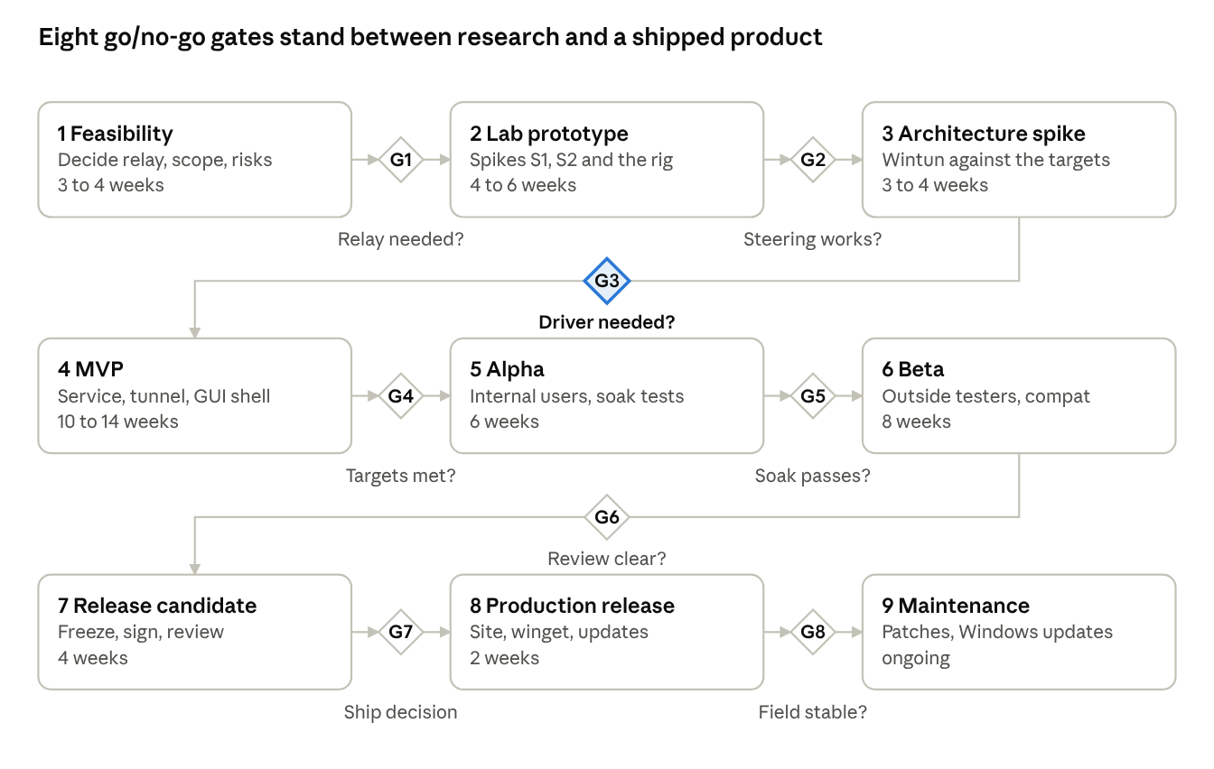
nine phases, eight go/no-go gates, not to scale
Bands are in order, not to scale. Durations are my proposal for a team of four or five engineers and should be reset after phase 2.
Phase | Main work products | Gate and pass criterion | Depends on | If the gate fails
1 Feasibility | Requirements, relay cost and delay model, threat sketch, licence review | G1: decisions 1 and 2 settled; relay model fits the budget | None | Narrow scope to flow-level balancing with no relay
2 Lab prototype | Spike S1 (steering), Spike S2 (Wintun plus UDP tunnel on two links), emulated-link rig | G2: S1 forces traffic out of each uplink; S2 carries traffic end to end | G1 | Test WinDivert or a WFP redirect before any driver work
3 Architecture spike | Packet-path benchmark of the Wintun route, IPC contract, interface wireframes | G3: Wintun path meets the proposed delay and CPU targets, so no driver; otherwise start an NDIS fast-path prototype | G2 | Fund the NDIS prototype and keep Wintun as the fallback
4 MVP | Service, scheduler, tunnel, relay, WinUI shell, signed installer | G4: the proposed acceptance table passes on the lab rig | G3 | Cut striping and ship flow-level mode only
5 Alpha | Internal users, support-bundle export, soak rig, crash reporting | G5: 72-hour soak and 100 resume cycles run clean | G4 | Fix, repeat the soak, delay beta
6 Beta | Outside testers on real carriers, compatibility matrix, outside security review, docs site live | G6: no open high-severity finding; matrix documented | G5 | Extend beta and patch
7 Release candidate | Feature freeze, signed installers and update feed, SBOM, rollback test | G7: release checklist signed off; rollback proven | G6 | Fix blockers and cut a new candidate
8 Production release | Public download, winget package, status page, support process | G8: first weeks of field data show no widespread failure | G7 | Roll back through the update feed
9 Maintenance | Monthly patches, regression runs on new Windows builds, relay capacity reviews | None; runs as a standing routine | G8 | Not applicable

Skills and tools matrix
The starting team needs deep Windows networking, protocol and performance skills; kernel-driver expertise can be hired or contracted only when a roadmap gate calls for it. Phase numbers match the roadmap: 1 Feasibility, 2 Lab prototype, 3 Architecture spike, 4 MVP, 5 Alpha, 6 Beta, 7 Release candidate, 8 Production release, 9 Maintenance.
Skill area | Used for | Tools | Level | Phases | Needed
Windows networking internals | Route tables, interface metrics, DNS and DHCP, weak and strong host behaviour, Spike S1 | PowerShell, route, netsh, pktmon | Expert | 1 to 4 | From day one
TCP/IP, NAT, MTU and congestion control | Scheduler, tunnel sizing, loss and reordering analysis | Wireshark, iperf3, netem | Expert | 1 to 7 | From day one
Protocol and cryptography engineering | Handshake, framing, reorder buffer, key rotation | Rust, protocol specs, test vectors | Advanced | 2 to 6 | From day one
Concurrency and performance | Packet path, batching, queues, cache behaviour | ETW, Windows Performance Analyzer, profilers | Advanced | 3 to 7 | From day one
Windows services, IPC and installers | Service lifecycle, named pipes, upgrade and rollback | Service Control Manager, WiX or MSIX tooling, Sysinternals | Advanced | 3 to 8 | From day one
Kernel driver engineering | WFP callouts, NDIS filter or miniport, only if a gate requires it | WDK, Visual Studio, WinDbg, Driver Verifier, HLK | Expert | Decide in 3; build in 4 to 8 | Later, on trigger
Security and threat modelling | Trust boundaries, fuzzing, secure update, external review | Threat-model workshops, fuzzers, Driver Verifier | Advanced | 2 to 8 | Part-time from start; outside review before 6
Desktop UI and accessibility | WinUI 3 screens, tray flyout, screen-reader support | Visual Studio, Windows App SDK, Narrator | Advanced | 3 to 8 | From the architecture spike
Test automation and lab networks | Emulated links, soak tests, regression runs | GitHub Actions, Hyper-V, netem, iperf3 | Advanced | 2 to 9 | From day one
Release engineering | Signing, SBOM, CI/CD, winget, update feed | Azure Artifact Signing or OV certificate, GitHub Actions, winget | Intermediate | 4 to 9 | Before alpha
Observability and support | Support bundles, crash dumps, trace analysis | ETW, WinDbg, Windows Performance Analyzer | Intermediate | 5 to 9 | Before alpha
Technical writing and web | Docs site, quick start, release notes | Starlight or Docusaurus, Markdown | Intermediate | 3 to 9 | From MVP
Relay operations and product support | Relay hosting, cost tracking, abuse handling, customer support | Linux administration, monitoring | Intermediate | 5 to 9 | Before beta

Risks, open decisions and next actions
The biggest risk is commercial, not technical: single-flow bonding only works with a relay, so the relay's cost and location decide whether the product is viable.
Rank | Risk | Experiment that reduces it
1 | Relay running cost and distance eat the gain from bonding | Cost and round-trip model for two candidate regions, using lab traffic profiles
2 | User mode cannot reliably force traffic out of a chosen uplink | Spike S1 on Windows 11 with several adapter types
3 | Unequal links (cellular against Wi-Fi) make bonded speed worse than the best single link | Emulated links with a 40 ms delay gap; tune the reorder buffer; keep flow-level mode as the fallback
4 | Wintun's packet copies miss the delay or CPU targets | Spike S2 measurements decide the NDIS fast-path gate
5 | Driver signing, memory integrity or SBOM rules delay a driver release | Prototype signing early with a test machine; track the March 2027 rule
6 | Conflicts with VPN clients, security suites, Hyper-V or WSL2 | Early compatibility matrix, repeated each milestone
7 | Carrier network address translation or plan limits break UDP paths or meter heavily | Test several carriers; add a path-quality warning in the interface
8 | Licence terms: Wintun source is GPL 2.0 and WinDivert is LGPL 3 or GPL 2 | Counsel review before choosing either as a shipped component
9 | Stale routes after sleep, crash or adapter removal | Soak test with forced crashes and resume cycles
Decisions I need from you
- Is single-flow bandwidth aggregation a hard requirement, or is flow-level balancing with seamless failover enough?
- Will you operate the relays, or must the product work without any server you run?
- Should traffic stay blocked or flow unprotected when every uplink or the relay is down?
- Is Windows 10 support required?
- Will the product be closed source? That affects which components you can ship.
Next actions, in order
- Settle decisions 1 and 2, since they set the whole architecture.
- Run Spike S1 (uplink steering) and Spike S2 (Wintun plus a UDP tunnel to a relay across two links).
- Build the lab with emulated links and record baselines.
- Build the relay cost and delay model for two regions.
- Hold a threat-model session and a licence review.
- Pick the docs framework and set up the repository, CI and a signing account.

Sources and assumptions
Pages I opened (a few long ones only in part), accessed in October 2026:
- Driver signing options, Microsoft Learn
- NDIS filter drivers, Microsoft Learn
- Introduction to WFP callout drivers, Microsoft Learn
- Virtualization-based security and memory integrity, Microsoft Learn
- Code signing options for Windows apps, Microsoft Learn
- Windows App SDK 2.0 release notes, Microsoft Learn
- .NET support policy, Microsoft
- Wintun, WireGuard project
- WinDivert, GitHub
- windows-drivers-rs, Microsoft, GitHub
- RFC 8684, Multipath TCP, IETF
- draft-ietf-quic-multipath, IETF
Pages I saw only as search results, so treat their claims as unconfirmed:
- Master's thesis on MPTCP and Windows, UCLouvain, 2024
- SBOM and VEX requirement report, ElevenForum, quoting Microsoft's certification blog
- Memory integrity default report, Windows Central
- Azure Artifact Signing report, DevClass, January 2026
- Starlight review, Docsio
- Networking driver samples, Microsoft Learn
Assumptions A1 to A4 are listed under Requirements and scope. Not verified at all: the IP_UNICAST_IF and strong or weak host behaviour on current Windows 11 (Spike S1 tests it), every performance target (proposed, never measured), Windows 11 support for WinDivert, and WinUI 3's Windows 10 1809 minimum (seen only in a README excerpt).

